Education for All
Priorities
July 2014

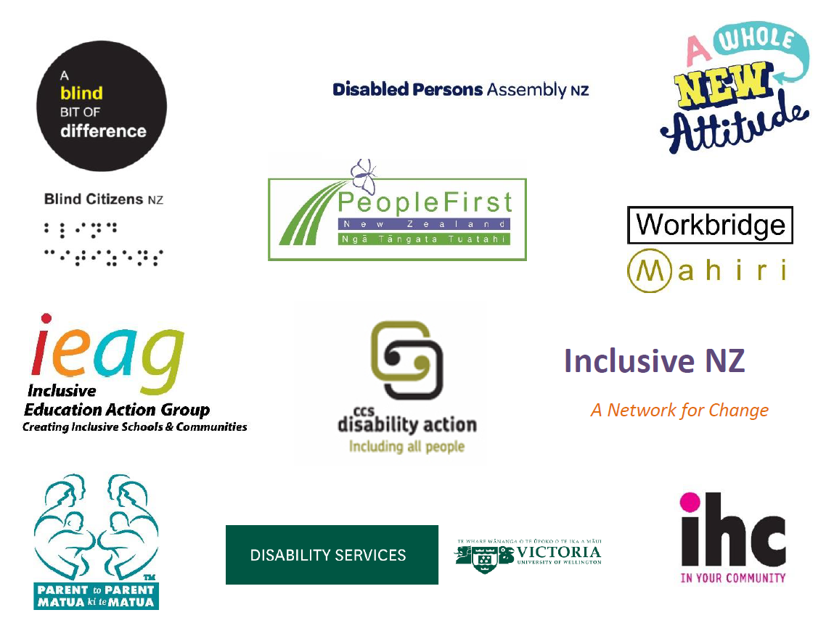
Preamble
Education For All (EFA) is a collaboration of disabled persons organisations, family and inclusive education organisations, teachers, and school principals, leaders, researchers and academics in inclusive education, and people from the employment and human rights sector committed to ensuring all students with disabilities are well educated in an inclusive education system.
The voices of Disabled people and their families have a key leadership role in articulating the rights and aspirations of disabled students and their family-whanau members in education. We have expertise in this field and as outlined in 4.3 of the Convention of the Rights of People with Disabilities, we are committed to working in partnership with the government.
We have developed this plan together to advise and engage meaningfully with government and the education sector because the government has a responsibility to respond to the rights of people with disabilities. The plan is relevant to the education and equal participation of disabled people and their families-whanau from early childhood through to and including tertiary and adult education.
What we mean by ‘inclusive education’
Inclusive education is a human right (United Nations General Assembly, 2007). Inclusive education means every person, social, and cultural group experience a quality, inclusive education and that all students experience lifelong benefits of participating, succeeding and achieving in an education system that actively values their identity. Our vision for inclusive education is based on the United Nations Conventions and declarations on universal human rights (United Nations General Assembly, 1948), and the rights of children (1994), persons with disabilities (2007) and indigenous peoples (2007).
Inclusive education is central to the development of inclusive communities and enhancing positive lifelong outcomes.
Article 24 of the United Nations Convention on the Rights of Persons with Disabilities (UNCRPD) establishes the right of disabled citizens to an inclusive education. Article 24 states:
With a view to realizing this right without discrimination and on the basis of equal opportunity, States Parties shall ensure an inclusive education system at all levels... and ensure that:
- Persons with disabilities are not excluded from the general education system on the basis of disability, and that children with disabilities are not excluded from free and compulsory primary education, or from secondary education, on the basis of disability
- Persons with disabilities can access an inclusive, quality and free primary education and secondary education on an equal basis with others in the communities in which they live
- Reasonable accommodation of the individual’s requirements is provided
- Persons with disabilities receive the support required, within the general education system, to facilitate their effective education
- Effective individualised support measures are provided in environments that maximize academic and social development, consistent with the goal of full inclusion.”
Children’s entitlement rights in other legislation are respected and valued, this includes citizenship.
Students with disabilities have full access to any accommodations they need to participate and succeed in education.
Inclusive education has been acknowledged as the most appropriate way for Governments to guarantee the right to education for disabled people.
Human Rights Council. (2013) “Thematic study on the right of persons with disabilities to education. Report of the Office of the United Nations High Commissioner for Human Rights”. P 7.

EDUCATION FOR ALL Priorities for action
- Well-adjusted students, schools and communities
- Government agencies, schools and all education settings work in partnership with disabled students and parents, families, and communities to advance positive systemic changes in education
- The experiences, voices and leadership of disabled people, families and their allies are fundamental to transforming education to quality inclusive education
- Schools and communities demonstrate inclusive values, where positive language use and respectful attitudes to disability and diversity are modelled, demonstrated and encouraged at every level of the education system
- Include initiatives to promote the value of diversity
- Disabled students value their own identity and feel connected with others like themselves
- All students are provided with opportunities to learn about disability history, culture and rights
- The capacity of education (teachers, early childhood centres, schools, tertiary providers, Ministry of Education) and society to value, include and contribute to the participation and success of disabled people is embedded in the system
- The government work in partnership with us to set and monitor specific participation, achievement targets and completion rates for disabled students (including at the tertiary level)
- Raising the participation and achievement of levels of children and young people with disabilities within education, alongside Maori and Pasifika students are included as a strategic priority within the Government’s Better Public Service goals.
- Confident and capable education settings
- Teaching approaches and practices are situated within a human rights framework, underpinned by social model understandings of disability, and based on research evidence for the effective delivery of Te Whaariki and the NZ Curriculum
- Nationwide provision of whole school professional development and mentoring to support every school to develop and sustain a culture and practices needed to ensure the learning, achievement and success of every student
- Graduating teacher standards include
  - A compulsory specific competency on how to include and teach students with disabilities.
  - Demonstrated knowledge of the likely impact particular disabilities may have on student participation and learning
  - Teacher education providers partner with disabled people to provide this training
- Registered teacher criteria include a demonstrated ability to respond effectively to students with disabilities
- All registered teachers are required to undertake professional development in inclusive education as part of the registration process
- New Zealand teacher education providers, schools, teachers and teacher’s aides receive professional development on how to plan and teach for diverse learners, including principles and practices of Universal Design for Learning (UDL)
- Ensure the compulsory full implementation of Kia Orite (code of practice) across tertiary institutions
- Tertiary programmes are relevant and lead to meaningful career pathways
- The government takes affirmative action to enable disabled people to become teachers.
- Strong leadership for inclusive education
- The participation, learning and success of disabled students in New Zealand schools is understood and approached as a human rights issue
- Disabled people and families are involved at every level of the education system
- Schools, students and families experiencing difficulties have access to direction, information, advocacy, mentoring, mediation and support
- Government agencies, and education settings (early childhood centres, schools and tertiary settings) encourage and support co-governance mechanisms that provide on-going evidence of seeking, listening, respecting and being responsive to the voices, experiences , concerns and rights of disabled students and parents, and their families
- Families are supported by schools to network with each other and establish channels for disabled student-whanau voice and decision making.

- Accountability, monitoring and enforcement
- The government complies with the non-negotiable standard of ensuring every student’s right to an inclusive education , including disabled students (UNCRPD, article 24)
- Government agencies, including Boards of Trustees, Ministry of Education, Education Review Office) routinely and thoroughly collect, analyse and publish quantitative and qualitative data on the prevalence of disabled children, young people and adults’ and their experiences, participation and achievement in education and use this information for:
  - School and teacher self-reviews
  - Allocation of resources
  - The development of effective education strategies for individual students with disabilities requiring accommodations to learn
  - Reviewing the framework and resourcing of SE2000 so as to remove inequities and ensure all disabled students have an equal right to education with other students
- Identify and remove the barriers and disincentives to the successful, inclusive education of disabled students
- The Ministry of Education builds and implements robust and effective mechanisms for the monitoring, accountability and enforcement of disabled students’ rights to benefit equally from participating, achieving and succeeding in education (Independent Monitoring Mechanism of the Convention on the Rights of Persons with Disabilities, June 2012)
- That the Ministry of Education establish an independent complaints and facilitation process for disabled students, parents and families which provides for their human rights to be recognised and responded to
- Issues and complaints are recorded, followed up and reported on. National data is collected on the reporting, responses, resolutions, and remedies to complaints and concerns
- A governance body is established to direct and monitor progress in inclusive education, this body would include Disabled Person’s Assembly, disabled peoples organisations, disabled people, families and disability leaders with a role to advise on the direction of inclusive education for disabled people.

____________________________________________________

